Computer Project 3. Predator-Prey Equations

1. As t increases, the aphid population decreases while the ladybug population increases. The aphid population appears to asymptotically approach close to 300,000. It will never approach 300,000. The ladybug population exceeds 2 million. X= aphids population and Y= ladybug population. Note: The first plot is simply a zoomed out view of the second one.

Plots:

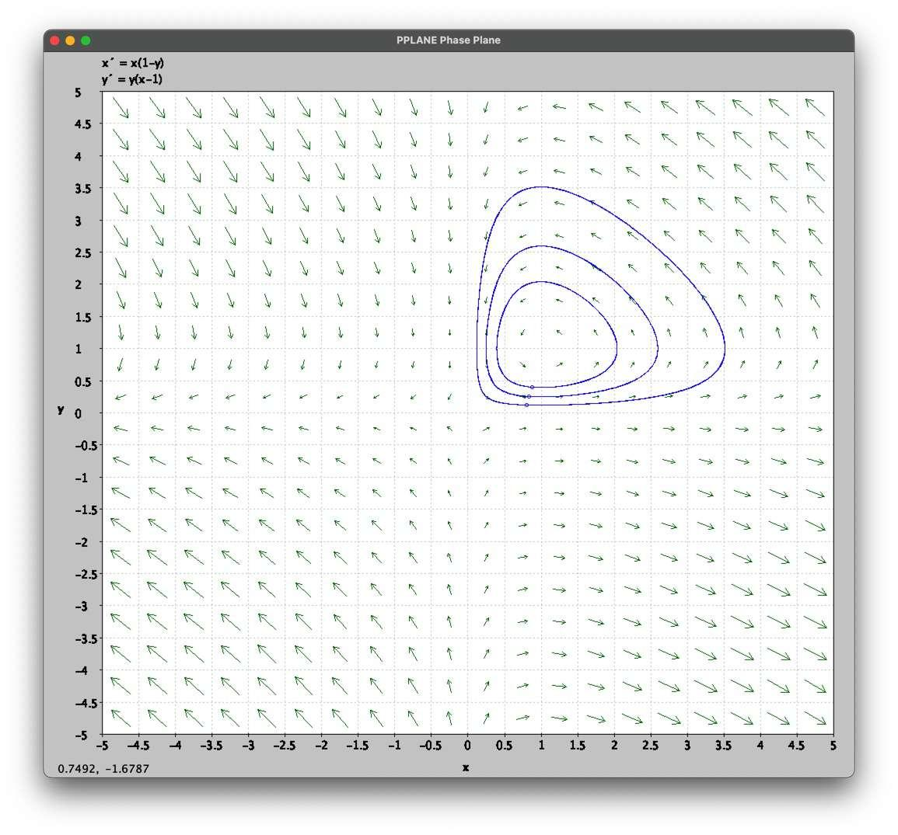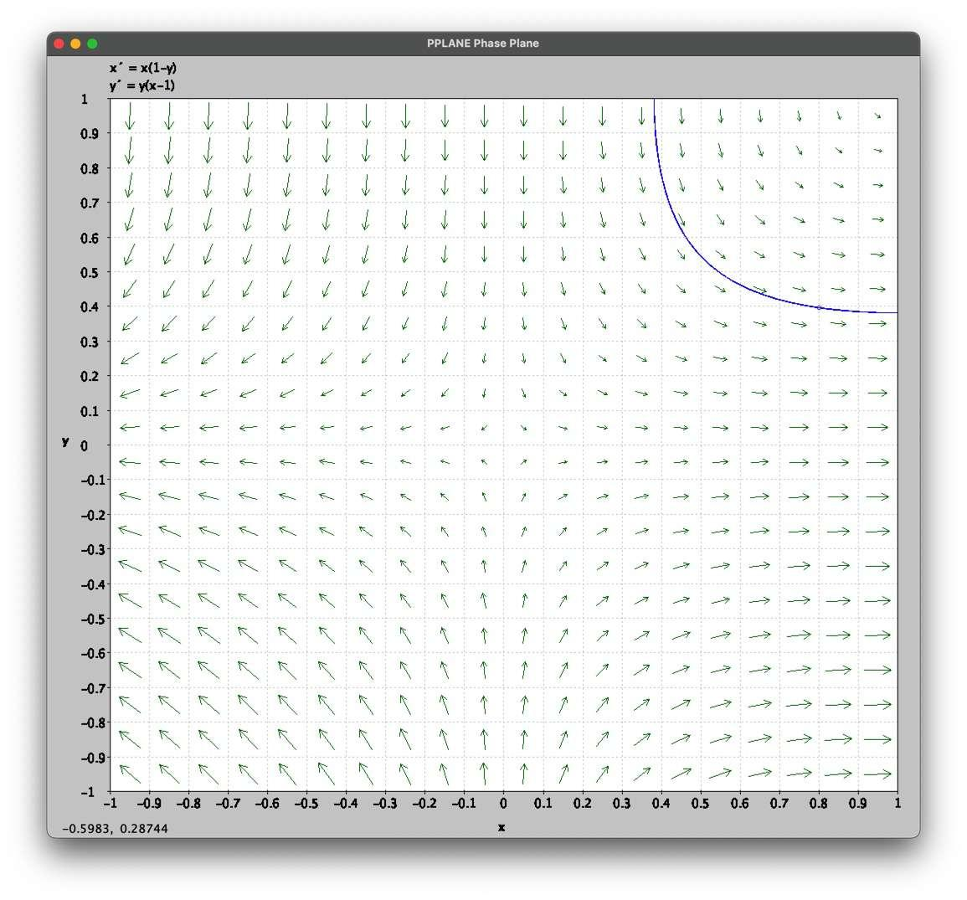

1. The aphid population will never be totally eradicated. To be honest though, this graph doesn’t seem like it’s accurate. If it is, then I might be reading it wrong. However, I think my answer is still right :D

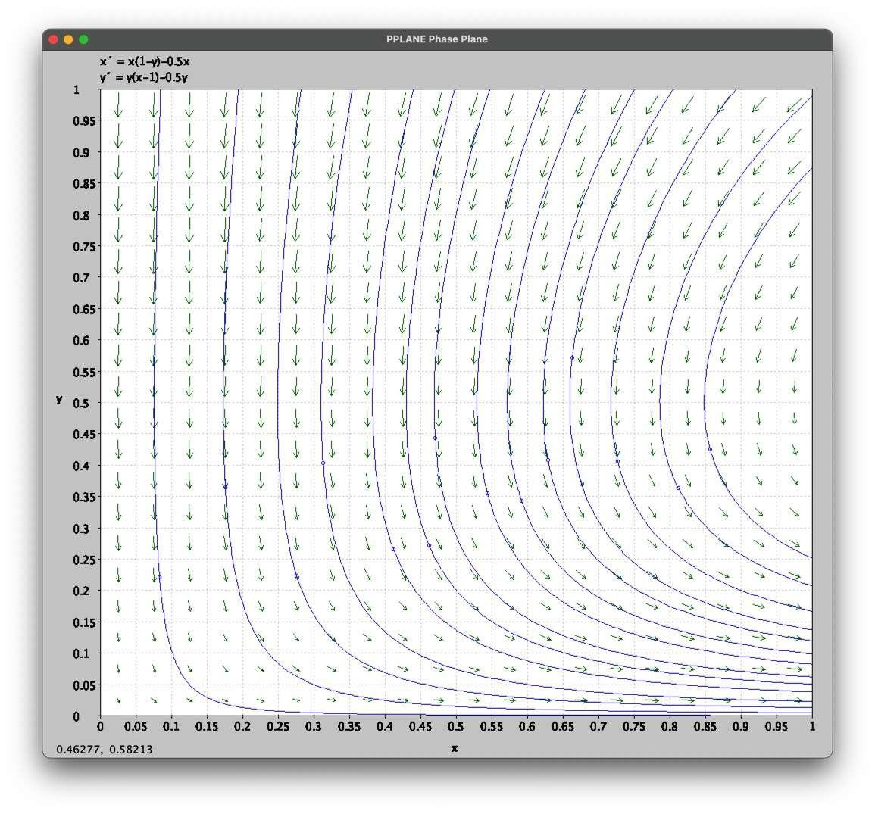

1. The following graphs have s=0, s=0.5, s=0.75 respectively. I would recommend using s=0.5 because it never exceeds or even reach 2.6 million.

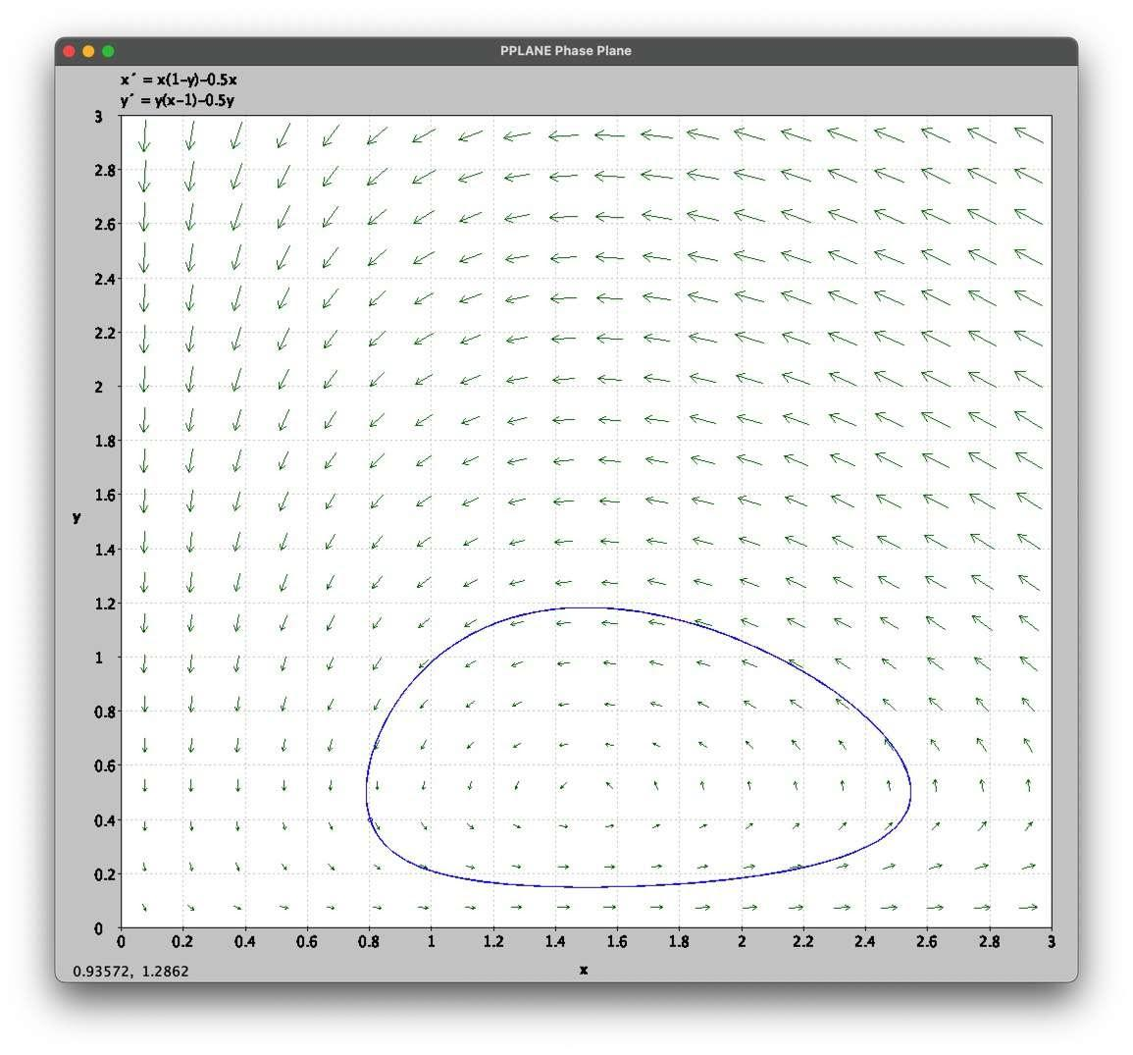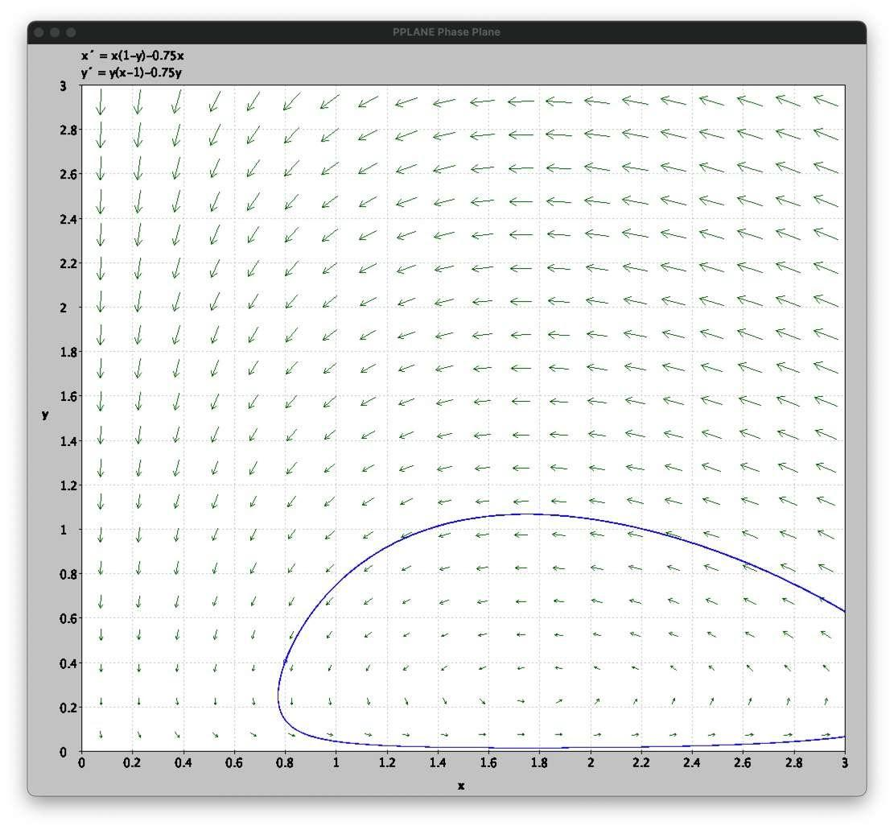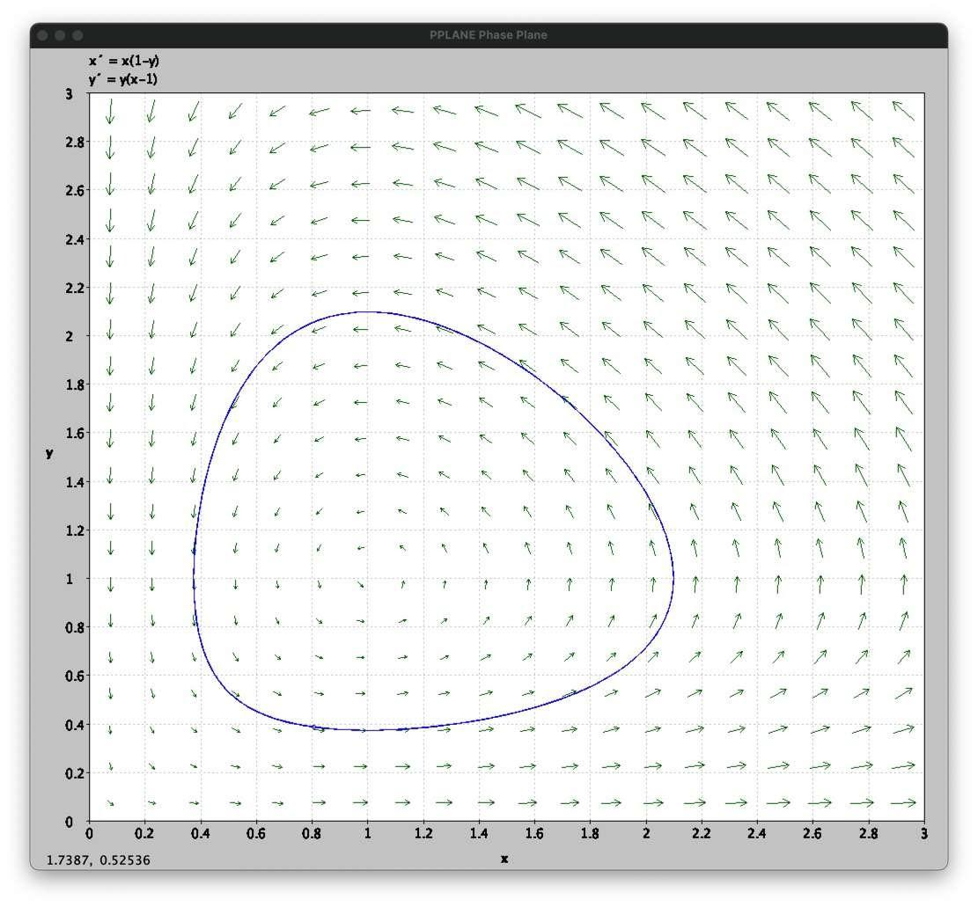

1. If the lady uses a pesticide with s=1.5, the populations of both the aphids and the ladybugs would probably be completely killed. This wouldn’t be a smart choice as the ladybugs are predators and killing them off would bring (possibly) more insects.

